Innovative Strategies
Name
Institution
Date

Innovative Strategies
Innovation is a very key tool that can help investors susceptible. Actually innovative strategies are very key in the today world of business. Every company focuses on creating a supportive environment that allows for innovations. I chose random companies with no basis to elaborate on innovative strategies.
Company | Innovative strategy | Product/service | Impact
Amazon | Huge investment in Research and Development. | Amazon kindle  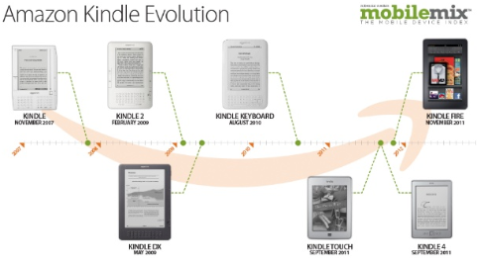  Amazon drones  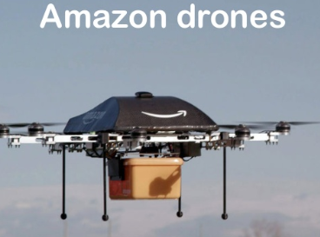 | The sale of eBooks grew immensely. More room for books was created among customers.  Drones: increased the overall company sales. 
Apple Inc. | The company has an ‘Innovation Factory’ that harnesses uncontrollable creativity. Through it, the company is sure to come up with ideas and trends that people will patronize globally (Apple Inc., 2018).  Apple Inc. also spends 3% of its revenues for R&D (The Telegraph, 2016). | The iPhone – smartphone  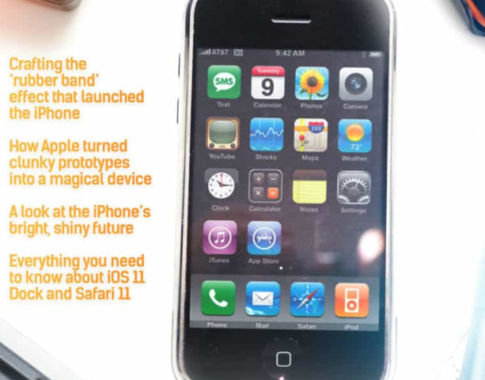  This device has been the most selling in this company. It has been updated to better version over the years to address consumer needs.  iPod –personal media player  This device was introduced in 2001 masterminded by Steve Jobs. It is a device whose design is outstanding, it’s easy to use, and has superb performance – the iPod phenomenon. | Incremental and radical changes in the company. The innovation of these devices has established a brand for the Apple Inc. hence growing a huge market for the products. Other products that are handy to these devices have also been invented, e.g. ios store.  The rapid innovation has made the company’s share price rise from 9 USD in 2000 to around 155 USD today (GuruFocus, 2018).
Walmart Inc. | Walmart’s innovation strategy is centered on reinventing retail in the current digital age.  The company has a technology and ecommerce committee.  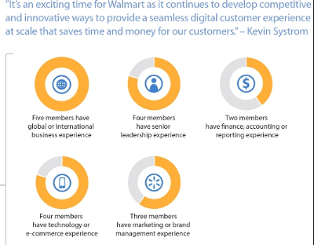 | E-commerce companies, like Amazon and Online shopping.  Other services are depicted in the below media:   | This company has never spared expenses to modernize. Customers have used online kiosks more conveniently, as well as the company’s app to make purchases hence saving time and other minor costs.  This has improved the sales volume of the company and it’s actually the strategy that developed the company to one of the world’s leading retailer with a net revenue of above 500 billion USD (Bold business, 2019).
Coca cola | Coca cola has partnered with potential entities to help leverage its innovation.  The company’s leadership has been consumer-centric. | Mobile Coca cola vending machine that delivers drinks and smiles  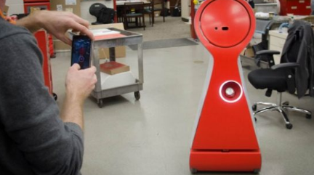  Coke’s BillBoss App which enables customers to pay like bosses.   | One of the most immediate result that every innovation brings to a company is the boosting of sale volumes.  These strategies have increased the company’s revenue base, leave alone the increased market capitalization.
Unilever plc. | The company works on a wide portfolio of projects incorporating the search for extensive technologies purposely to respond to competitive forces. Other goals that drive innovation in the company is the urge to produce sustainable products and meet the demands for a wide market.  Huge investment of R&D; e.g. innovation lab | Beauty and personal care products       | The company has been able to increase its shareholders base following some of these mighty innovations they have made.  Profit wise, the Unilever Plc. Has increased its profits immensely form these innovations as well as earning customer trusts over the time.  Share price of the company has increased tremendously.

Requirements to effectively innovate. To innovate, I will need to:
To achieve successful innovation, highly trained leaders are required so that they can ignite a spirit of creativity hence a culture of innovation.
Create strategic partnerships and manage them; strategic partnerships has the advantages of fostering growth, increasing innovation’s leverage, and risk is lowered. Alliances really help even solicit funds for the case of individual innovators.
Huge investment is very crucial for an innovation journey since the product has to be prototyped for testing so that any improvements that may be needed can be addressed before marketing the same. This is why some steps have to be taken, like partnerships.
Support is very important – support from the customers or clients that will have to use the product you have in mind. They will be there to purchase your product in the initial stages for testing and would really refer friends and friends of friends hence helping boost initial sales.
References
Apple’s Greatest Innovations (2016) The Telegraph, Available at: http://www.telegraph.co.uk/technology/picture-galleries/6099399/Top-10-Apple-innovations.html
Bold Business (2019). Walmart’s Innovation Strategy – Reinventing Retail in the Digital Age. https://www.boldbusiness.com/digital/walmart-innovation-strategy/
Kelvin Claveria, (2017). Visioncritical: 3 lessons from coca cola’s global innovation community. https://www.visioncritical.com/coca-cola-global-innovation-community/
The everything store: Jeff Bezos and the age of Amazon, Brad Stone (2013)

